An Investigation Into What Causes Crash Injuries, Fatalities

Using association analysis on crash data from the City of Chicago

Nabil Darwich  
 Department of Computer Science  
 George Mason University  
 Fairfax VA USA  
 ndarwich@gmu.edu

Hamza Mughal  
 Department of Computer Science  
 George Mason University  
 Fairfax VA USA  
 hmughal2@gmu.edu

ABSTRACT

Being able to save human life is one of the most important goals facing various communities. An unfortunately common reality in which lives are lost is due to car accidents, and there are always public service announcements to advise on avoiding them. In this paper, an analysis is conducted regarding the true factors that lead to injuries and fatalities when it comes to car crashes. Data from the City of Chicago, during the summer of 2018, is used to find out what some of these causes are, and a model is built to determine accident severity outcomes given the elements involved. The summer season was picked to minimize external factors such as snow and road conditions leading to crashes, and the most recent summer was that of the current year, 2018. We use this data to build a training model, and evaluate how it performs against a never seen before test set (summer 2017) A goal from this paper is to raise awareness regarding what can be done to avoid such tragedies.

1 Introduction – Data Analysis

1.1 - Data

Data from the city of Chicago had 1.1M+ records split to 3 datasets (Crashes, Vehicles, People). The crash dataset has 48 features, Vehicles has 29, and People has 71. For this report, we consider records from Summer 2018 (training) and Summer 2017 (test).

1.2 - Visualization of Car Accidents in Chicago

During the summer of 2018, there were approximately thirty thousand recorded car crashes in Chicago as reported by the police department. Recorded information about these crashes ranged from data about the incident’s occurrence, such as geolocation, to data about the driver, such as their sex.

Mapping the geolocations with matplotlib’s pyplot yielded an image similar to the shape of Chicago as can be seen here:

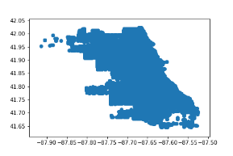

Not being able to discern much information from this map, though, we decided to plot each accident against an actual map of Chicago. This was accomplished using Baseplot in python along with associated helper files. Mapping the accidents on an actual map yielded much more informational results:

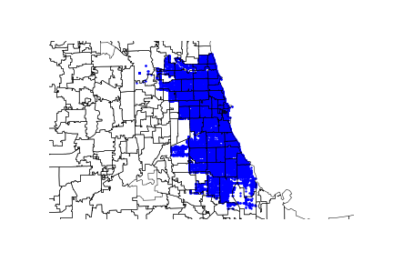

While this graph was helpful in visualizing our data, it was very intriguing how one location in the Southeast had very few crashes. Thus, an investigation into why that is the case took place. The population map of Chicago revealed that only a few individuals lived in that location, with a vast majority of them choosing to live along the center of Chicago, rather than its outskirts.

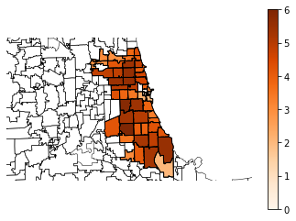

From the population density map, the suspicion that most car accidents would occur throughout the densest areas of Chicago naturally came about, and mapping the accidents against the population densities seemed to corroborate our hypothesis:

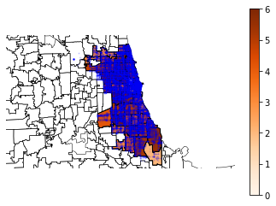

As can be seen, the outskirts of Chicago have fewer accidents, with most accidents being in the center of Chicago, where it is most dense in terms of population.

**1.3 - Analysis of Chicago Accidents**

Prior to data mining work, it was also insightful to find that some obvious patterns in the data were confirmed when the data was graphed. But in other times, the answer did not seem as intuitive as originally thought. Using the summer 2018 data, this is what we found:

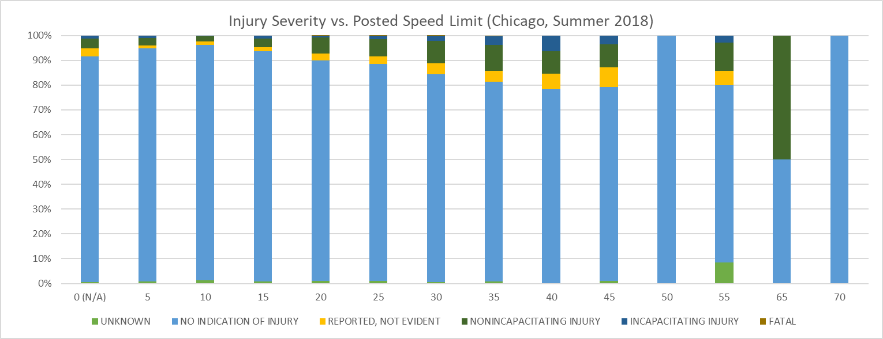

Figure 1: Injury Severity vs. Posted Speed Limit

In here, the intuitive thought that roads that have higher speed limits are involved in more severe crashes was confirmed. The x-axis in Figure 1 is the posted speed limit where a crash occurred, and the y-axis is the % occurrence of each accident severity. As can be seen, accident severities gradually get worse as the speed limit is increased. There are a few outliers when it came to higher speed limits, due to lack of data involving the same road conditions. As an example, only one crash happened when the speed limit was 70 during the summer of 2018, and fortunately, no serious injuries occurred. Due to this anomaly, however, a suggestion that roads that have a speed limit of 70 have a 100% survival rate may arise, which is definitely a false conclusion.

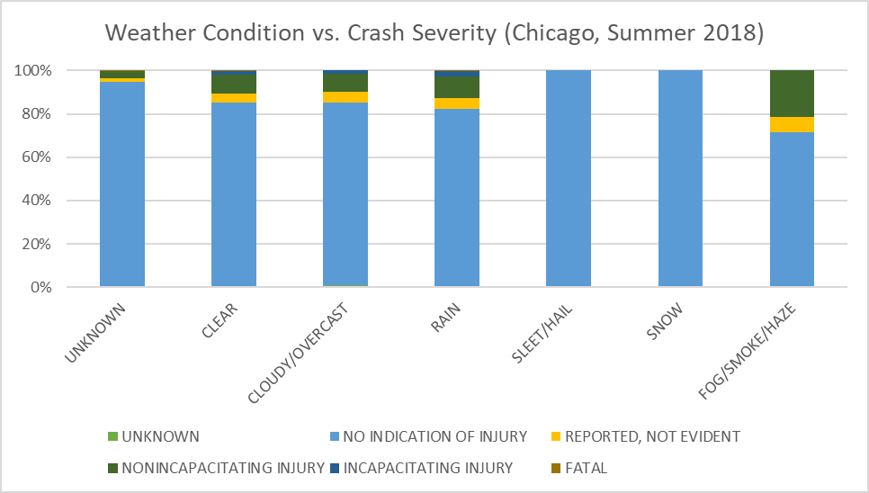

Figure 2: Weather Condition vs. Crash Severity

A somewhat intuitive graph that was also generated involved the severity of the crash when it came to weather conditions (Fig. 2). As it can be seen, rainy days involved much more injuries than clear/overcast days. But what came in as very surprising is the amount of injuries and fatalities that occurred during foggy/smoky/hazy days, which far exceeds rainy days. However, this graph may also lead to a few false conclusions, as one can draw that injuries never occur during days with snow or hail, but again, this was only due to the infrequency of data elements in that subset, as snow/hail rarely occurred in Chicago during the 2018 summer.

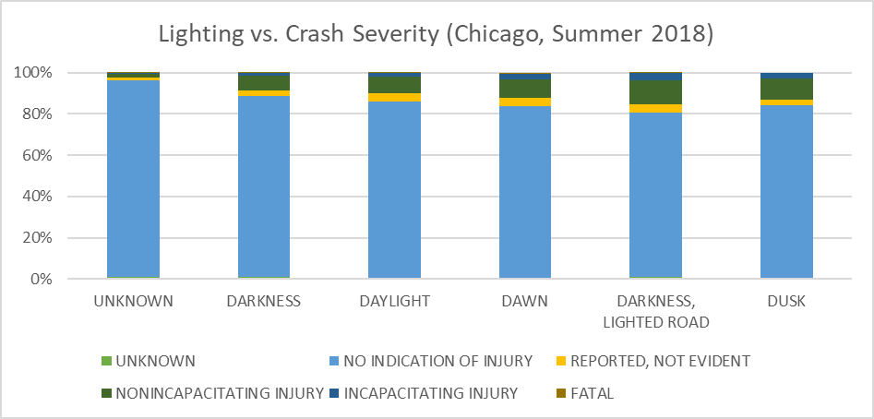

Figure 3: Lighting vs. Crash Severity

The last graph that was generated during pre-data mining analysis was the lighting conditions at the time when the crash occurred. The results here were also consistent with natural biases, where crashes that occurred at night involved much more injuries than daylight. However, it was surprising to find out that in pitch darkness, without any streetlights to light up the path, crashes that involved injuries were relatively infrequent when compared to crashes that occurred during daylight. A possible explanation for this phenomenon may be that streets with pitch darkness are not as populous as streets where streetlights have been installed, and individuals there are much more cautious when driving.

2 Solution

2.1 - Data Preprocessing

Preprocessing was the most gruesome but crucial step in our process. Modifying the data set such that it keeps the same meaning and be interpreted by a data mining algorithm is a challenging task faced by many data scientists and statisticians.

**2.1.1 – Selecting a Training Sample**

The original City of Chicago car crash data set was divided into 3 separate datasets that contained more than 200,000 that date as far back as 2014. Those datasets were contained information about the following:

1. The crash itself (date, weather, lighting, primary cause, …) [1]

2. The people involved (age, sex, injury classification, …) [2]

3. The vehicles involved in the crash (make, model, year, …) [3]

We have come to notice that vehicle data was largely sparse and infeasible to deal with and discretize without any general vehicle descriptions (i.e.: size of the vehicle). So, we agreed to only deal with information about the crashes and individuals involved.

Next. we have come to realize that different seasons often meant different reasons for crashes. For example, roads will be in much rougher conditions during winter months, and that information is not necessarily captured by the datasets. We did not want these details to bias our results, so, we decided to only deal with summer data for this project, with dates ranging [6/21, 9/21]. Finally, when it came to the year, we decided to select 2018 as our training year to build the most accurate and up to date model that reflected current regulations and road conditions. We decided to use summer 2017 data for testing, and summer data from the other years was used for our training model.

**2.1.2 – Combining Crashes and People**

With two distinct datasets, crashes and people, our next challenge was combining them into one. The two tables both featured a column called RD_NO, which stood for the report number of the crash. For each individual, the report number was the crash they were involved in, so multiple individuals often showed up with the same report number. With that in mind, a left outer join was done from people onto crashes based on the report number column being equivalent. The Excel formula for accomplishing this feat was:

IFERROR(VLOOKUP($A2, crashes!$A:$AN,7,FALSE),"")

Which roughly translated to, if a report number for an individual existed in the crashes table, concatenate the crash details to the individual. Applying the formula to all individuals in the workbook created a table that had information about every individual merged with details about the crash they were involved in.

**2.1.3 – Discretization (binning)**

With crashes and people now merged into one, allowing algorithms to operate on the data was next. For that to happen we had to transform each cell from a label {DARKNESS, DAWN, DAYLIGHT, DUSK} to a number {0, 1, 2, 3}. We decided to enumerate the values for each column, doing so initially required a manual inspection of the data and recording of those unique values. Once unique strings were recorded, a mapping was created to allow for a translation from raw strings to numerical data.

Later on in our process, we felt the compulsion to also discretize age data, which was already numerical, and we did so by grouping it {CHILD, YOUNG ADULT, SENIOR, etc..} then enumerating it as well {0, 1, 2, …}.

**2.1.5 – Feature Reduction**

Numerous columns were found to have no use as they were either redundant, irrelevant, or represented a consequent that we’re not aiming to determine. Examples of such columns included duplicated columns, report numbers, and if the individual was transported to an Emergency Room. As these columns hindered our training model, we simply eliminated them.

**2.1.6 – Project Goal**

All features by now were either antecedents or general details about the subject/environment. The one consequent that was kept was INJURY_CLASSIFICATION, which indicated the severity of the injury that was sustained by the individual, and it was one of:

0. NO INDICATION OF INJURY

0. ~~REPORTED INJURY, NO EVIDENCE~~

1. NONINCAPACITATING INJURY

2. INCAPACITATING INJURY

3. FATAL

Predicting INJURY_CLASSIFICATION became the goal for this investigation. Recently, however, we revisited the possible values for injury classification, and found that *REPORTED INJURY, NO EVIDENCE* was not a feasible class to predict for our purposes, and it only misled the algorithms that we followed. The goal of this investigation is to find when injuries do occur, not when people report them without any basis. We decided to indicate anyone classified as an REPORTED INJURY, NO EVIDENCE to have NO INDICATION OF INJURY.

2.2 - Transformation

**2.2.1 - Oversampling**

When looking over the data, we noticed a large discrepancy between the number of non-injuries and fatal injuries. Analyzing this discrepancy showed that 91% of crashes didn’t involve any injuries and only 0.05% involved a fatality (though we are thankful that that was the case).

To lessen the bias towards non-injuries, as well as preserve their details, we chose to oversample the data. Our dataset of 67,346 individuals with unbalanced injury classifications became one with 181,737 individuals, with repeated entries of underrepresented instances to balance all injury classifications.

**2.2.2 – Refining Features**

More feature trimming felt necessary as multiple features were still either infrequent or unimportant. To eliminate those remaining features, we used SKLearn’s SelectKBest, scoring the features based on a chi squared statistic, and selecting the 20 best features in the dataset. At the end of feature refinement, we had 181,737 individuals with 20 features each to determine injury classification

**2.2.3 – Reverting to Strings**

Our dataset consisted of oversampled numbers at this point, but since we were planning to use association analysis, we were required to revert to the original strings before the mapping. We did so by using Python Dictionaries, converting numbers to their mapped strings. After that, we were ready to start training our model.

2.3 - Data Mining

**2.3.1 – Weka**

We settled on using the Weka software by the University of Waikato to continue with our investigation. WEKA provides various utilities that vastly help when it comes to association rule mining and classification.

**2.3.2 – Association Analysis & Classification**

Before dealing with classification, we were interested in what precursors lead to fatalities. To accomplish this, class association rules (CAR) was set to true with the class index being set to 18 to indicate Injury Classification as the consequent (as a minor note, setting a specific consequent will only output Confidence so we will not be displaying other metrics, such as Lift). The minimum confidence was set to 0.3, and the lower bound minimum support was set to .0001 (this meant that for an item to be considered frequent, it must have appeared in at least.0001% of the data).

After running association analysis with these parameters on the training data, we found an few interesting rules, such as:

SEX=M SAFETY_EQUIPMENT=SAFETY BELT NOT USED==> INJURY_CLASSIFICATION=FATAL conf:(0.9)

An interpretation of this rule would be being a male while not wearing a safety belt means a likely fatality after a crash.

Weka was used to do classification. Given our dataset we decided on primarily using Naïve Bayes, Random Tree, and Random Forest.

**2.3.3 – Naïve Bayes**

Naïve Bayes is a basic probability-based classifier which assumes the independent nature of features. This independence assumption makes the classification fast. The advantage of using Naïve Bayes with is that it is linearly scalable with the number of features and can be used for multi class classification problem prediction.

Given that we have a multi class problem, we chose to see how Naïve Bayes would perform when it came to classification.

**2.3.4 – Random Tree**

Random Tree is a supervised classifier in which there are many individual learners deployed. Bagging is used to produce random sets which are used to construct a decision tree where each node is split on the best split among variables. The Random Tree algorithm is relatively quick and works well with many features. Considering our features, we knew Random Tree would be a good fit as our data, at a glance, fit like a tree meaning there were many different edges to different injury classifications.

**2.3.5 – Random Forest**

Random Forest chooses X number of trees to grow on different samples of data. Once all the trees are grown, an input gets assigned a label based off the majority vote of all the trees. Random Forest is an excellent classifier in terms of accuracy and handles large data quite easy however it takes some time to build the model and to classify. As with Random Tree, we expect Random Forest to perform well for the same reasons.

**2.3.6 – Performance Metric**

Given that our dataset has a large class imbalance between fatalities and non-injuries, we opted for F1 Score as our performance metric. Also considering that we are trying to accurately predict injuries and fatalities, we are interested in the number of false positive/false negatives which F1 considers.

**2.3.7 – Classification on Training Data**

We ran the above classifiers on the training data to see how well the classifier learned the model with a 10-fold split for testing on the training data with the label as Injury Classification.

|  |  |  |  |  |  |
| --- | --- | --- | --- | --- | --- |
| Classifier | %Correct | %Incorrect | Precision | Recall | F1 |
| Naïve Bayes | 66.8 | 33.1 | .66 | .69 | .66 |
| Random Tree | 96.9 | 3.1 | .97 | .97 | .97 |
| Random Forest | 98.5 | 1.5 | .99 | .99 | .99 |

Confusion matrixes for each classifier were as follows…

**Naïve Bayes:**

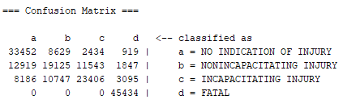

**Random Tree:**

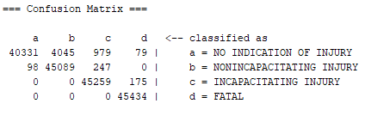

**Random Forest:**

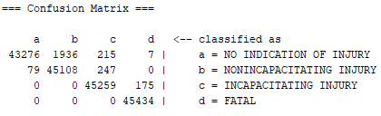

2.4 - Evaluation of Training Data

Out of the tree classifiers, Naïve Bayes performed the worst in terms of accuracy and F1 Score and Random Forest performed the best in terms of accuracy and F1 Score. Despite the F1 score for Naïve Bayes being the lowest, it classified all fatalities correctly with no false negatives.

The classifier looks as if it has learned the model exceptionally well as the accuracies for all three are above 50 percent however it is yet to be seen if there has been any sort of overfitting occurring.

3 Predicting Summer 2017 Labels

3.1 – Selecting a Test Sample

The classifiers performed relatively well on the training data, so we selected never seen data from Chicago Summer 2017 to test our classifiers. This contained 49,743 people entries.

3.2 – Matching Formats

For us to rerun our algorithms on the test set, the dataset had to go through a similar preprocessing phase described earlier. Summer 2017 People had to be merged with Crashes they were involved in again, and only 20 columns were kept. It was unnecessary this time to discretize the data due to already being formatted for WEKA classification. The only column that was significantly altered was the age, where we followed the same conventions that were specified during training. By now, we were ready to measure how our trained Summer 2018 classifiers would perform against a never seen before Summer 2017 test set.

3.3 – Prediction Results

The results of rerunning the same algorithms on the unseen test data were as follows:

|  |  |  |  |  |  |
| --- | --- | --- | --- | --- | --- |
| Classifier | %Correct | %Incorrect | Precision | Recall | F1 |
| Naïve Bayes | 70.5 | 29.5 | .94 | .71 | .79 |
| Random Tree | 88.8 | 11.2 | .91 | .89 | .90 |
| Random Forest | 92.4 | 7.6 | .92 | .92 | .92 |

3.3.1 – Confusion Matrices

**Naïve Bayes:**

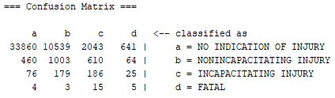

**Random Tree:**

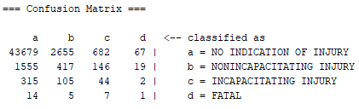

**Random Forest:**

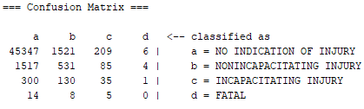

3.4 – Evaluation of Prediction Results

Initially we were worried that the model may have overfitted the test dataset as seen from the accuracies achieved on the training however that does not seem to be the case. The accuracies and F1 scores on the unseen test dataset were relatively high which tells us that the model indeed is not overfitting at all.

Naive Bayes performed the worst in terms of accuracy and F1 score, however, we found it to be our favorite model as it managed to predict the vast majority of fatalities as injuries or worse. It also performs significantly better when it came to injuries, being correct the majority of the time, unlike Random Tree/Random Forest. So, when it comes to saving human life, we choose Naïve Bayes as our favorite and most safety compliant model.

4 Conclusion

In conclusion, we have managed to address the problem we were trying to initially solve and managed to build a model out of ~69,000 individuals from the summer of 2018 and predicted the injury classification of around 49,000 individuals from the summer of 2017. We were very surprised to see how much information the misfortune of only 36 fatalities was able to bring to a never seen before dataset of ~49,000 individuals. The injuries and incapacitations helped significantly as well, and with this minimal model of only summer 2018 data, only 4 out of 27 summer 2017 fatalities were classified as no indication of injuries.

REFERENCES

[1] Traffic Crashes - Crashes | City of Chicago. (Updated Daily). Retrieved November 24, 2018, from <https://data.cityofchicago.org/Transportation/Traffic-Crashes-Crashes/85ca-t3if>

[2] Traffic Crashes - People | City of Chicago (Updated Daily). Retrieved November 24, 2018, from <https://data.cityofchicago.org/Transportation/Traffic-Crashes-People/u6pd-qa9d>

[3] Traffic Crashes - Vehicles | City of Chicago (Updated Daily). Retrieved November 24, 2018, from <https://data.cityofchicago.org/Transportation/Traffic-Crashes-Vehicles/68nd-jvt3>Conference Name:ACM Woodstock conferenceConference Short Name:WOODSTOCK’18Conference Location:El Paso, Texas USAISBN:978-1-4503-0000-0/18/06Year:2018

Date:June

Copyright Year:2018

Copyright Statement:rightsretained

DOI:10.1145/1234567890

RRH: F. Surname et al.

Price:$15.00